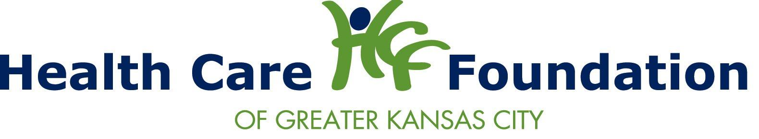

Program Logic Model Examples
Inputs | Activities | Outputs | Initial Outcomes | Intermediate Outcomes | Long-Term Outcomes
Standards  Curriculum  Baseline Measures  Trainer  Provider  Program Plan  Evaluation Plan  Location  Equipment | Logistics  Outreach  Training  Services  Pre-Post Data Collection  Analysis  Reporting Results | Number of  Participants who enroll and complete  Percent of target population who  complete  Number of times service is delivered  Number of pre/post surveys completed | Improved knowledge (measure by assessment)  Improved vital sign, according to indicator  Improved access (comparing with baseline utilization)  Client satisfaction  (measure by assessment) | Improved awareness, communication  Improvement in point-in-time measures  Improvements in outreach and program strategies  Creation of partnerships or sharing resources | Sustainable resource created  Ongoing use of new service delivery approach  Improved health condition  Existing service reaches new population  Improved public health indicator

Outcome Measurement Framework Examples
Outcomes | Indicator | Data Source | Data Collection Method
Knowledge of communication with HC professional | Increase of at least 10 points  in class average on pre/post knowledge assessment (survey) | Pre-Post Test | Administered by the trainer before and after the training
Improved attitude about HC communication | Increase of at least 10 points  in class average on pre/post knowledge assessment (survey) | Pre-Post Test | Administered by the trainer before and after the training
Improved management of medications | Participant brings completed and updated list of meds to final class | Verified by staff; collected from program records | Interview before final training session
Improved management of medications | Participant brings checklist completed by MD or pharmacist | Verified by staff; collected from program records | Home visit one month after final training session

